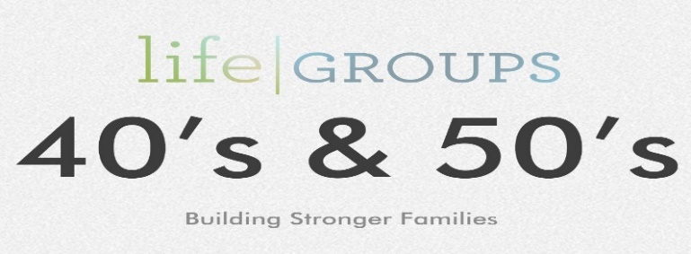
Debt
9-12-18

1967 college freshman were surveyed and asked this question: would you rather have a meaningful philosophy in life, or be financially independent? What would you guess their answer would be? In 1967 it was a meaningful philosophy in life; that changed in the late 80’s. We have become a nation of “I want”:

- Bigger and newer home
- New cars
- Fancy vacations
- Second homes
- The best in everything

The result has been families are incurring more and more debt, to get what they think they want.
Listen to Solomon’s advice: Ecclesiastes 5:10-20

Two Value systems:
- A worldly value system
- God centered value system

How does debt affect us?
Debt creates or fosters stress

Debt creates division or blame

Debt robs your family (vacations, fun, the opportunity to de-stress)

Debt does not allow you to take advantage of opportunities

Debt means you pay for things more than once

Debt is born out of discontentment

Truth’s about Money

- Chokes out spiritual truth.
Matthew 13:22
- Causes some to set their hopes on the wrong things.
1Tim.6:17
- Causes us to pursue things that don’t last.
Matt. 6:19-21
- Cash can become our master
Matt. 6:24

- We forget that it’s God who gives the power to make wealth.
Deut. 8:18

- Put God to the test. - Malachi 3:8

Questions:

- How does “debt”, affect us?

- What affects did you observe debt having on your family growing up?

- How have you seen it affect others?

- How can debt affect marriages? What issues do debts bring out?

- What are you teaching your kids about debt?

- Why is delayed gratification so difficult for us to accept?

